**Exprement 1:- LED FLASHER**

**Observations:-**

* When we pass electrical signals to the arduino through our code the LED glow and gets off accordingly.

**Problems and Troubleshooting:-**

The problems that may occur are as follows :-

* The LED bulb may not be working . We can replace the bulb with another one.
* The circuit may not get closed because the wires may not be placed at the right position so to solve this, we can change the position of the wires to the right position.

**Precautions:-**

The precautions that should be taken into consideration are-

The connections at different points should not be loose and the pins should be inserted properly.

**Circuit Diagram:-**

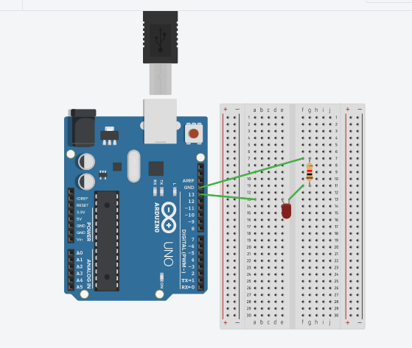

**Theory:-**

**Concept used:-**

The concepts used by me for doing this task can be listed as:-

* The arduino board can supply a power of 5v as digital output signals through the 14 pins (namely 0-13) present in it as digital input or output pins.
* The GND pin of the arduino board acts as ground.
* In the breadboard present in the above circuit diagram the two rows present at the top and bottom each, are connected with each other in series and the columns present in between are connected in a set of 5 each. The connection pattern is shown below: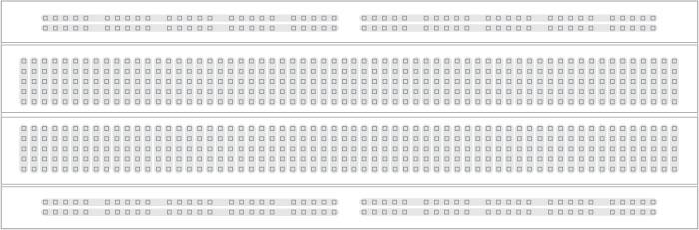

**Learning and Observation:-**

**Leanings:**

* To make a series circuit using an arduino board and a breadboard.
* An arduino works , current flows and it works.
* Working of LED and resister.
* The two pins of the LED should be connected at their appropriate point that is the positive point should be connected with the p pin and the negative point should be connected with the negative pin.
* We should take care that the circuit is closed .

**Learning Outcomes:-**

* To make circuits using an arduino board and a breadboard and some other hardwares.
* To make and design a circuit using codes. This further helped in understanding and correlating hardware with software.